SDR Sharp Installation/Use guide to Analyze Car Key Fob Frequency

- Go to www.airspy.com and go to Downloads. Download sdrsharp-x86.zip
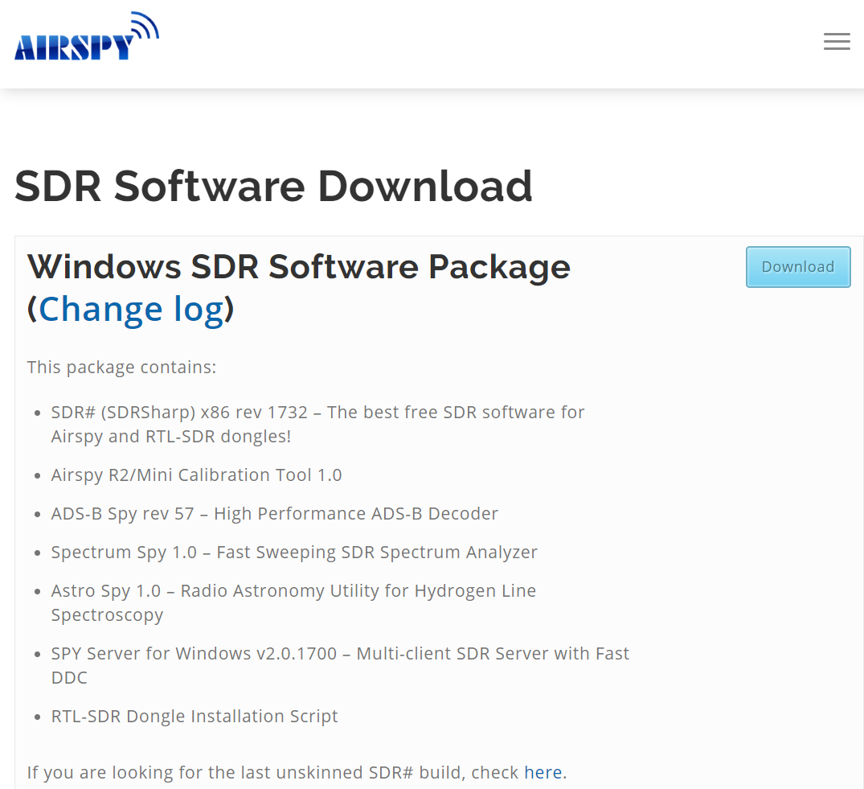
- Extract sdrsharp-x86.zip to a folder (Note: there are many files in this zip so it is best to make a new folder to extract to.)
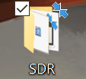

- Run the “install-rtlsdr.bat” file in your folder.

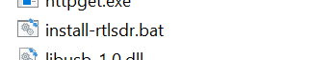

- Select Bulk In Interface 0, ensure that WinUSB is selected and click on Replace Driver.
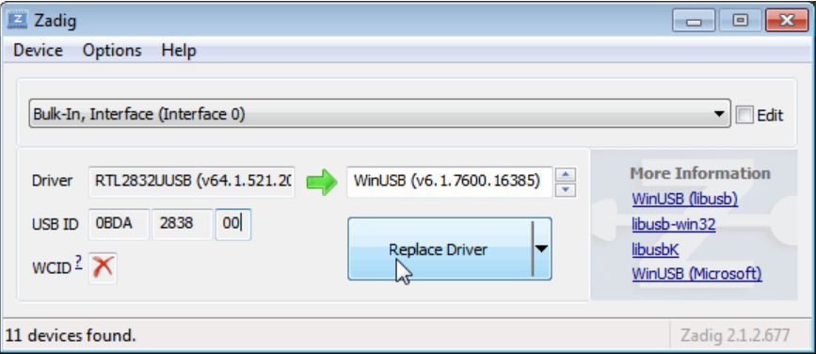

- Open SDRSharp.exe, this is the main software we will use to interact with our SDR.
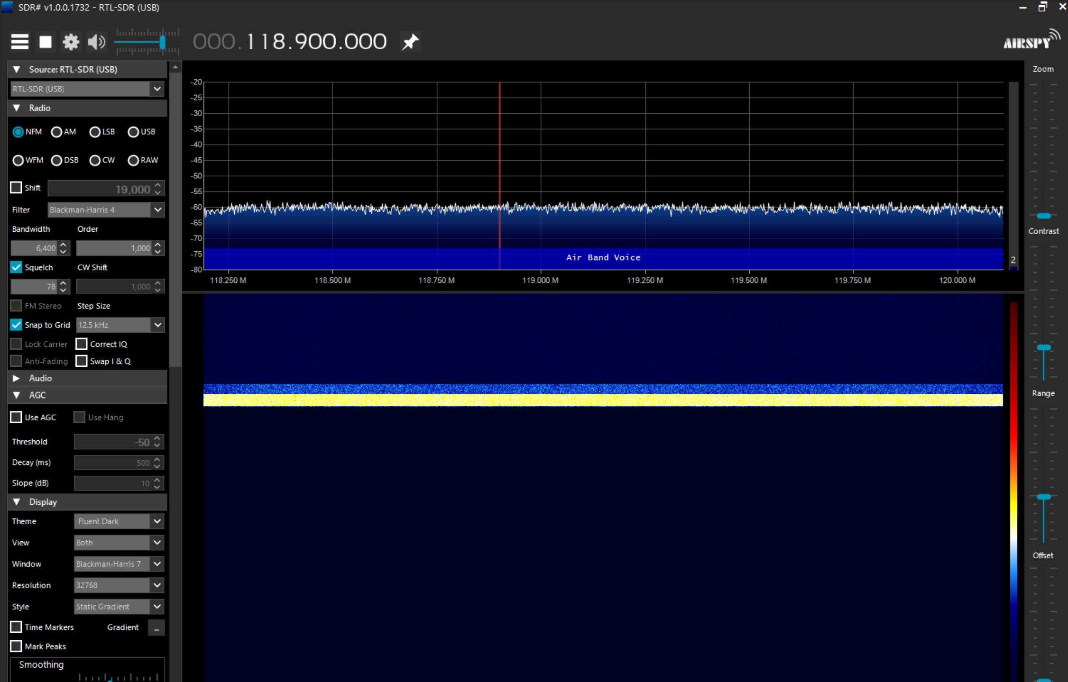

- Click on the Settings icon on the top right, and select your device. Important: RF gain is set to 0 by default, you won’t be able to pick up many frequencies like this. Raise the gain to about 25-35dB.
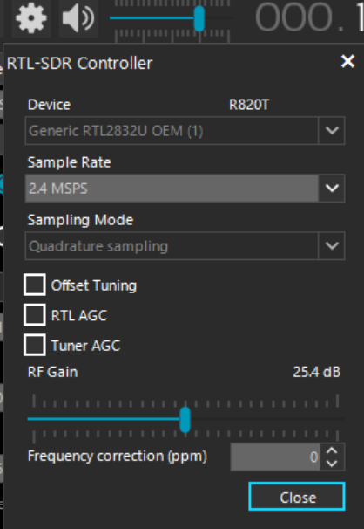

- Your SDR should now be ready to use. Click the Play button to start receiving frequencies. You can change the frequency you are listening to by clicking on the numbers on the top


Or you can also click on the frequency spectrum itself to change the listening frequency.
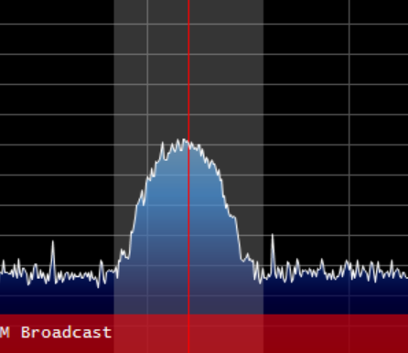

- On the bottom of the graph, you can see what kind of frequency range you are listening to. For example, the frequency range below is commonly used for Air traffic control (An easy to pick up frequency range is FM radio, 88-108 MHz.)
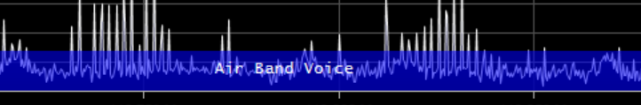

- Assuming you have an American car key fob like the one below, you should be able to listen in on its frequencies. Go to the 315 MHz frequency (European cars use 433.92 frequency) and click a button on your key fob. (Note: You might have to adjust the frequency a little bit depending on your specific key fob.)
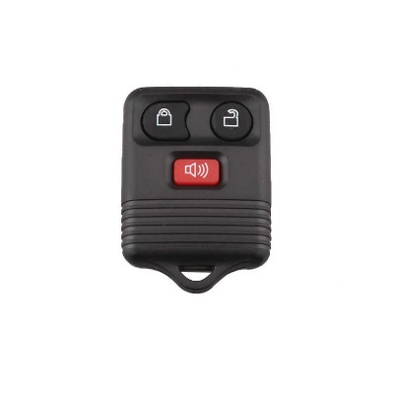
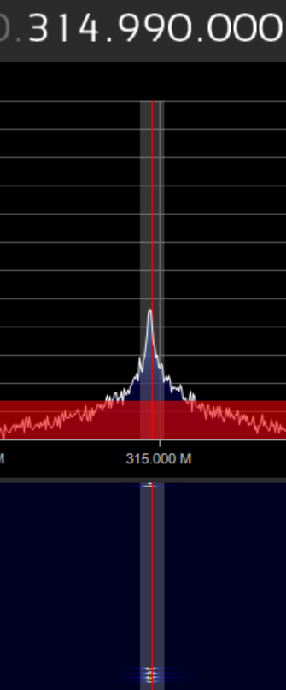

Useful tips:
SDR Sharp UI:
On the right side of the screen you have 4 different sliders.

Zoom- Allows you to zoom in and out on a specific frequency so you can fine-tune bandwith.
Contrast- Changes the color scheme on the frequencies picked up, this allows you to more clearly see what signals the SDR is picking up.
Range- Adjusts what frequencies you can see depending on their signal strength.
Offset- Vertically adjusts the positioning of the frequencies on the graph.

Radio Reference:
Radioreference.com A website that lists what frequencies are used by whom.
